The World Upside Down

1. (10 pt)  a. Vertical Asymptote(s):  b. Horizontal/Slant Asymptote(s):  c. Zeros:  d. y-intercept:  e. Hole _________________________  f. Sketch the graph of y = ƒ(x) and all significant features. | Be sure to label all important points.

2. (6 pt) Write the equations of ALL asymptotes of
Show your work and explain your reasoning.

3. a. (6 pt) Write the equation of a rational function that could fit the graph shown below.

b. (6 pt) On the same set of axes, sketch the reciprocal of the given function. Note all important features clearly.

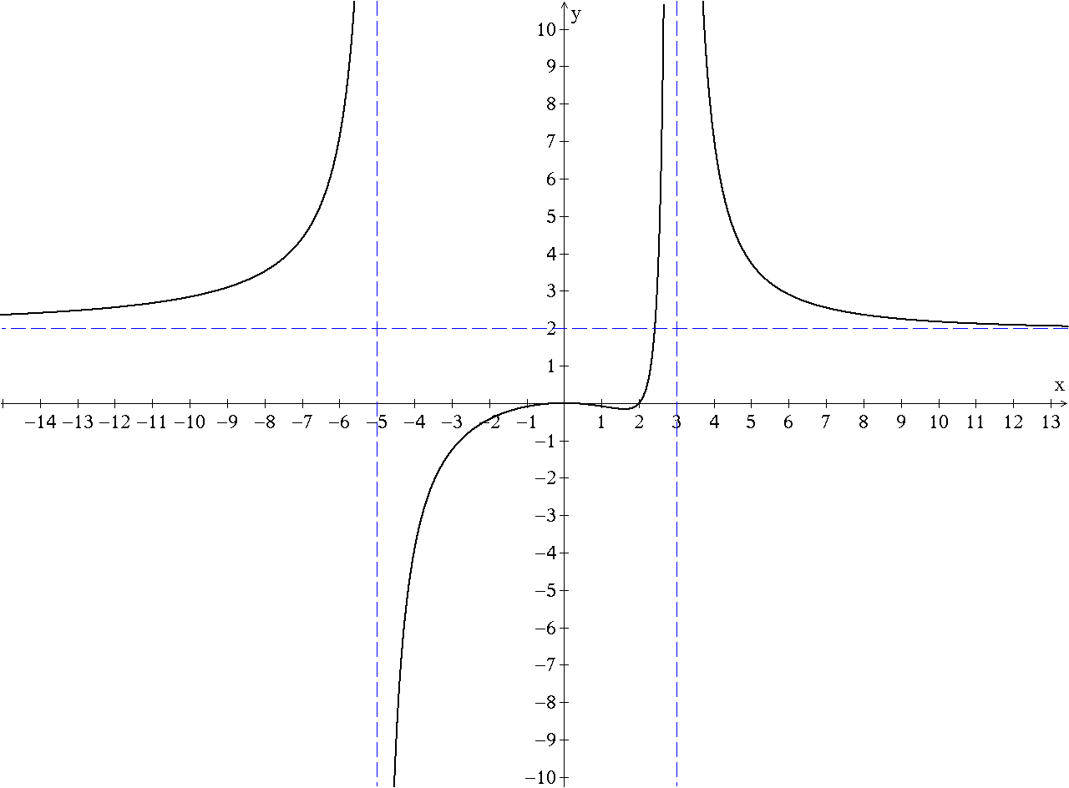

4. (5 pt) Write the equation of a rational function R(x), whose zeroes are 2 and –3, with a
hole at , a vertical asymptote at and horizontal asymptote at .

5. (5 pt) A students attempted to solve the inequality by multiplying both sides of the inequality by to get . This led to a solution of . Is the student correct? Explain.

6. (8 pt) The graph of is given below, with .
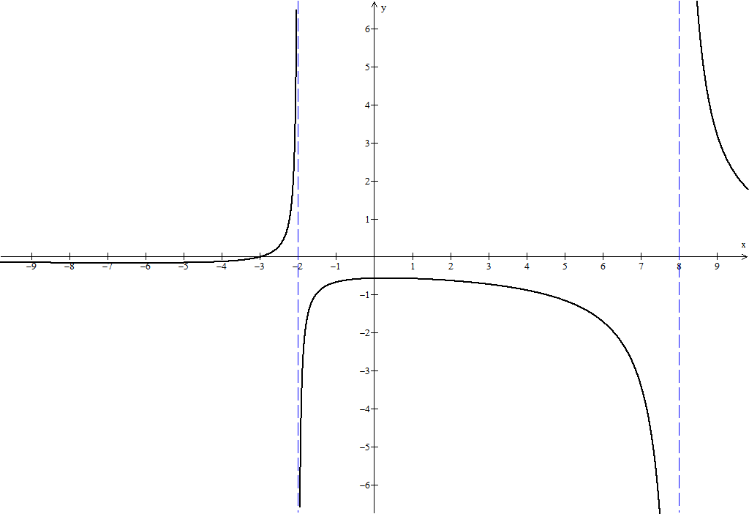

The value a is a parameter in the graph. Imagine in Winplot we create a slider that will change a from 8 to-4. Describe how the graph changes and at what values of a significant changes of the graph occur, and what those specific changes are. Briefly explain your reasoning.
Key

1)

